EXPERIMENT 2

Pandas Library – Basic Concept

Aim:

Upload and analyze the data set given in CSV format and perform data preprocessing and visualization.

Algorithm:

1. Import the required libraries — pandas, matplotlib, and seaborn.

2. Read the sales dataset using pd.read_csv() and display the first few records.

3. Check and display missing values in the dataset.

4. Display statistical summary of the dataset using describe().

5. Convert the Date column to datetime format.

6. Group data by Product and plot a bar chart showing total sales per product.

7. Group data by Date and plot a line chart showing total sales over time.

8. Create and display a pivot table of sales by Region and Product.

9. Compute the correlation matrix between Sales and Quantity, and display it using a heatmap.

Program:

import pandas as pd

import matplotlib.pyplot as plt

import seaborn as sns

df = pd.read_csv('C:\sales_data.csv')

print(df.head())

print("\nMissing Values in Dataset:")

print(df.isnull().sum())

print(df.describe())

df['Date'] = pd.to_datetime(df['Date'], format='%d-%m-%Y')

sales_by_product = df.groupby('Product')['Sales'].sum()

plt.figure(figsize=(6, 4))

sales_by_product.plot(kind='bar', color='skyblue')

plt.title('Total Sales by Product')

plt.ylabel('Sales')

plt.xlabel('Product')

plt.tight_layout()

plt.show()

plt.figure(figsize=(10, 5))

plt.plot(df.groupby('Date')['Sales'].sum())

plt.title('Total Sales Over Time')

plt.ylabel('Sales')

plt.xlabel('Date')

plt.tight_layout()

plt.show()

pivot_table = pd.pivot_table(df,

values='Sales',

index='Region',

columns='Product',

aggfunc='sum',

fill_value=0)

print("\nPivot Table: Sales by Region and Product")

print(pivot_table)

corr_matrix = df[['Sales', 'Quantity']].corr()

sns.heatmap(corr_matrix, annot=True, cmap='coolwarm')

plt.title('Correlation Matrix Heatmap')

plt.show()

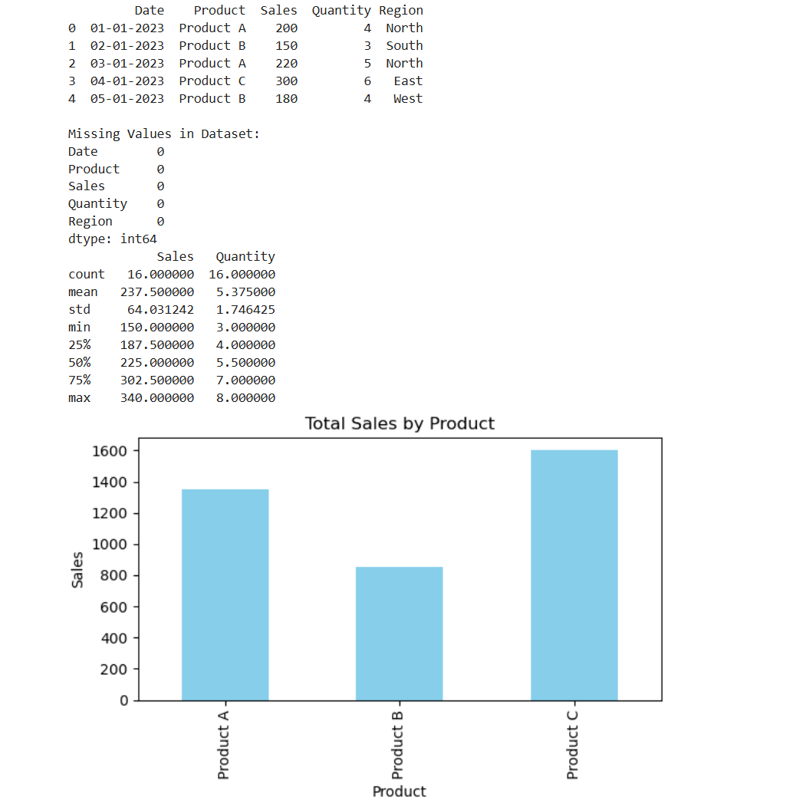Output:

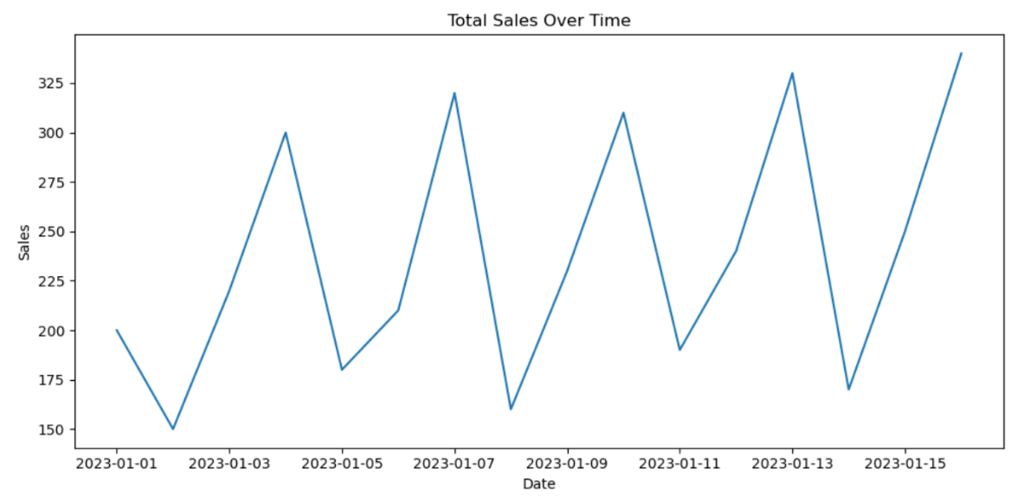

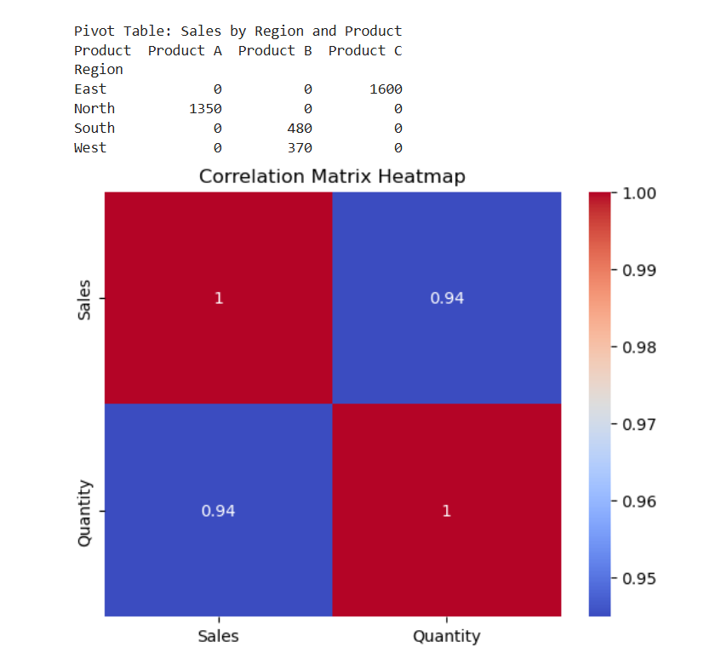

Result:

Hence a program to perform data preprocessing and visualization is written and executed successfully.